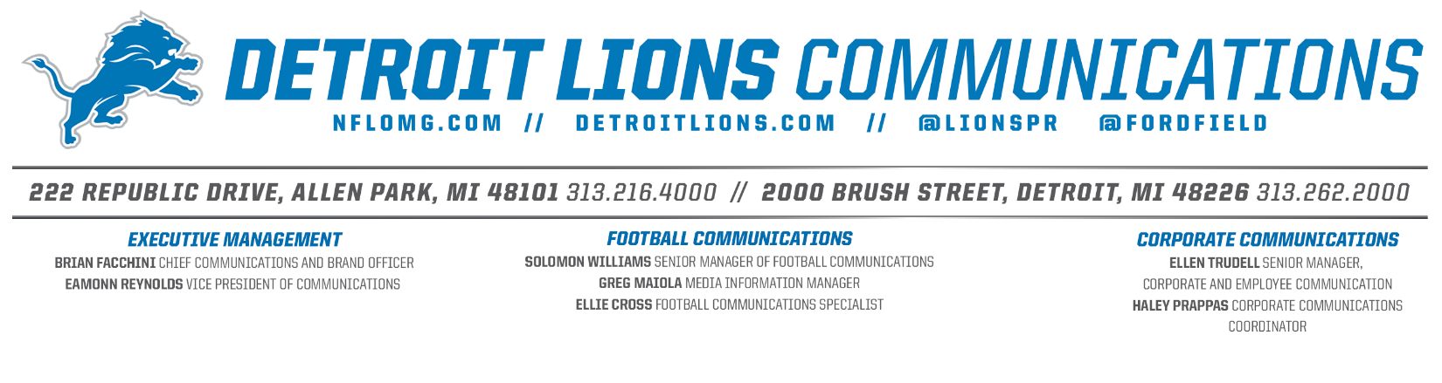

FOR IMMEDIATE RELEASE
SEPTEMBER 29, 2025
DETROIT LIONS AND KÖLN MARATHON ANNOUNCE PARTNERSHIP TO REACH SPORTS ENTHUSIASTS IN GERMANY

DETROIT – The Detroit Lions and the Köln Marathon (Cologne Marathon in English) have today announced a partnership to celebrate runners’ achievements on the racecourse while introducing the Lions brand to Germany’s running community.
“This partnership between the Detroit Lions and the Cologne Marathon is a unique and fun one,” said Senior Vice President, Marketing and Brand Emily Griffin. “We recognize how crucial sports and fitness are to the Cologne community and we were thrilled at the chance to not only commend that, but to tap into it directly by being a first-time partner at the race. We are excited to introduce new, potential fans to our team and to further integrate ourselves in the Cologne community, and country as a whole.”
At the 16 km mark of the marathon, the Detroit Lions will have a hotspot featuring the Detroit Lions Germany mascot Leo Löwe, a wave of Honolulu Blue banners, a DJ playing music by Detroit artists to energize runners and spectators, as well as a chance to win an autographed jersey and football. To further celebrate the runners, the Lions will give away 500 medal engravings through sweepstakes available in the Cologne Marathon Digital Goody Bag.
Since its inception in 1997, the Generali Cologne Marathon has been one of Germany's largest running events. On 5 October 2025, over 36,000 participants will take to the starting line for the marathon, half marathon, relay marathon, school marathon and children's run. The route, lined with tens of thousands of spectators, passes numerous sights on its way to the grand finale: the finish line at Cologne Cathedral, the city's landmark.

“We entered a partnership with the Detroit Lions because it builds bridges across different sports and connect sports enthusiasts internationally. This idea fits perfectly with the Cologne Marathon,” said Markus Frisch, CEO of the Cologne marathon.

This latest strategic partnership joins several others in the country as part of the Detroit Lions long-term strategy to expand efforts in Germany as part of the club’s 2024 entry into the NFL's Global Markets Program. First launched in 2022, the Global Markets Program awards NFL clubs international marketing rights to build brand awareness and fandom beyond the U.S. through fan engagement, events and commercial opportunities. NFL clubs can apply for rights to international markets by submitting proposals to the International Committee for review each year. Clubs are awarded rights for at least a five-year term through the program, and during this period can pursue activities in that international market that are consistent with what they can do in their home market.

Fans can stay up to date on the Detroit Lions in Germany through Instagram and TikTok at @detroitlionsdeutsch.

#30#

MEDIA CONTACT FOR THE DETROIT LIONS
Ellen Trudell (ellen.trudell@lions.nfl.net)

MEDIA CONTACT FOR KÖLN MARATHON
Jan Broniecki (broniecki@ausdauersport.koeln)

ABOUT THE DETROIT LIONS
The Detroit Lions are a professional American football team based in Detroit, Michigan. They are members of the North Division of the National Football Conference (NFC) in the National Football League (NFL) and play their home games at Ford Field in downtown Detroit. The team was located to Detroit in 1934 and is the NFL's fifth oldest franchise. The Detroit Lions’ most recent NFL postseason appearance was the Divisional round after securing a back-to-back NFC North title following a franchise-high 15-2 record during the 2024 season. For more information, please visit www.detroitlions.com.

